Sukkur IBA University
Software Design Specification (SDS)

Group Members:

Supervisor:
Mr. Noor Nabi Dahar

Project Code
Internal Supervisor | Mr. Noor Nabi Dahar
External Supervisor
Project Manager
Project Team
Submission Date

Supervisor Signature

Document History

Version | Name of Groupmates | Date | Description of change
1.0 |  | 20/12/2024 | Document Created
1.0 |  | 25/12/2024 | Added Use Case Diagram
1.0 |  | 30/12/2024 | Added Sequence Diagrams
1.0 |  | 05/01/2025 | Added Test cases
1.0 |  | 10/01/2025 | Added Interface Design
1.0 |  | 15/01/2025 | Added ERD diagram of System
1.0 |  | 18/01/2025 | Added Database Diagram
1.0 |  | 22/01/2025 | Added Class Diagram
1.0 |  | 30/01/2025 | Reviewed whole document

Distribution List

Name | Role
 | External Supervisor
 | Project Manager
 | Project Lead
 | Project Member

Document Sign-Off

Version | Sign-off Authority | Project Role | Sign-off Date
 | Mr. Noor Nabi Dahar | Project Supervisor

Table of Contents

Table of Contents | 4
1. Introduction of Design Document | 1
2. Entity Relationship Diagram (ERD) | 5
3.Use case Diagram | 6
3. Sequence Diagrams | 7
4. Sequence Diagrams | 7
4.1 Sign up Sequence Diagram: | 8
4.2 Sign-in Sequence Diagram: | 9
4.3 Create Event Sequence Diagram: | 10
5. Architecture Design Diagram | 11
6. Database Diagram | 12
7. Class Diagram | 13
8. Interface Design | 14
9. Test Cases: | 17
10. References | 25
11. Appendices | 26

Introduction of Design Document
This Software Design Specification (SDS) document provides a well-structured, diagrammatic design and description of the SIBA Inventory Hub. It outlines the system’s high-level architecture, functional modules, and technical components, ensuring clarity in implementation. The document includes Entity Relationship Diagram (ERD), Sequence
Diagrams, Use Case Diagram, Architecture Design Diagram, Database Diagram, Class Diagram, Interface Design, and Test Cases, offering a comprehensive framework for development, scalability, and maintenance.

Entity Relationship Diagram (ERD)
The system uses a NoSQL MongoDB database, with entities as collections and records as documents. The ERD shows how Users place Requisitions, which link to Inventory items and optional Suppliers.

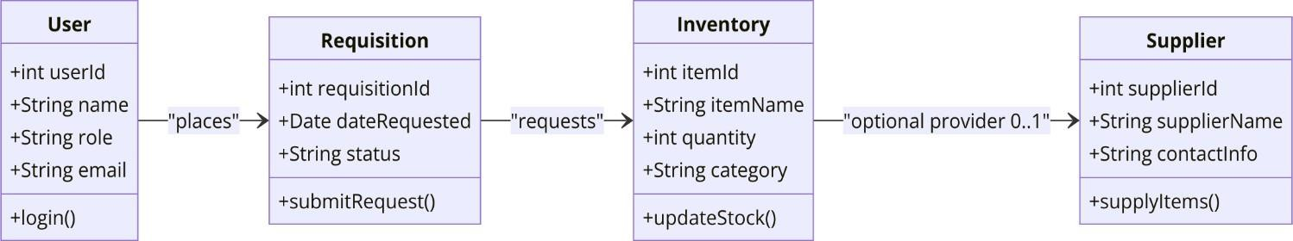
Figure 1-ERD

Use Case Diagram:

This Use Case Diagram illustrates the roles and responsibilities of Admin, Faculty, and Staff within the Inventory Management System. It highlights their key tasks, such as managing users, approving requisitions, tracking stock levels, and scanning QR codes, ensuring smooth and efficient inventory operations.

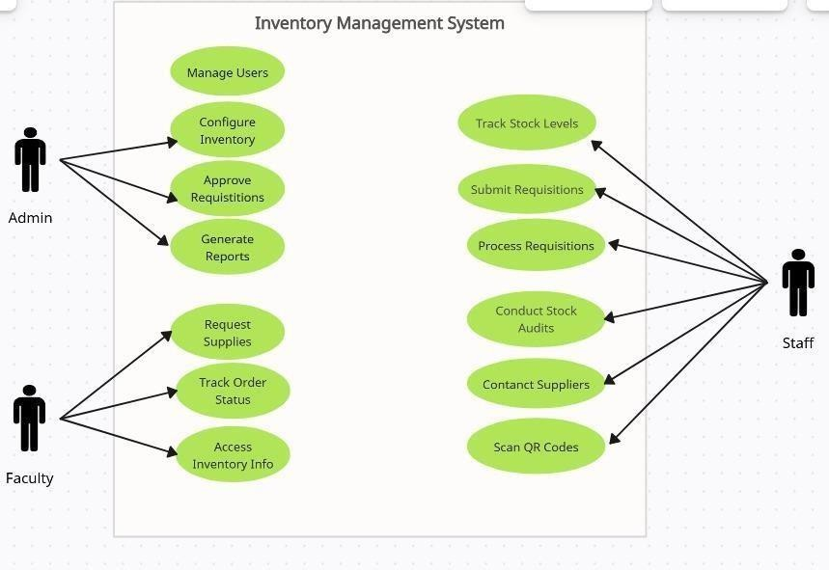
- Use Case Diagram

Sequence Diagram:

This Sequence Diagram is representing the interaction flow between Admin, Staff, Faculty, the Inventory Management System (IMS), and the QR Code Scanner. It demonstrates key processes such as managing users, approving requisitions, submitting requests, updating inventory via QR codes, and tracking order status.

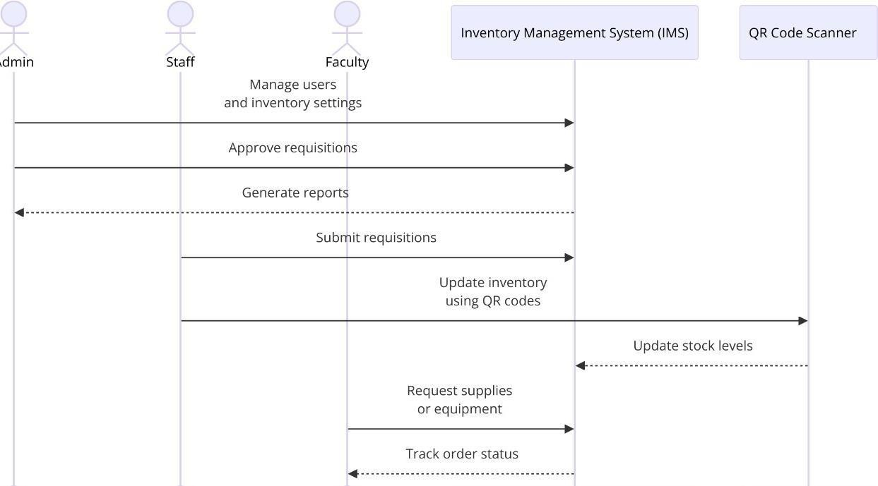
- Sequence Diagram

Sign-up Sequence diagram :

This is a sequence diagram illustrating the steps involved in a user's sign-up process for a web application. It shows the interactions between the user, the web application, and the database. The diagram uses an 'alt' to show the different paths depending on whether the email address is already registered.

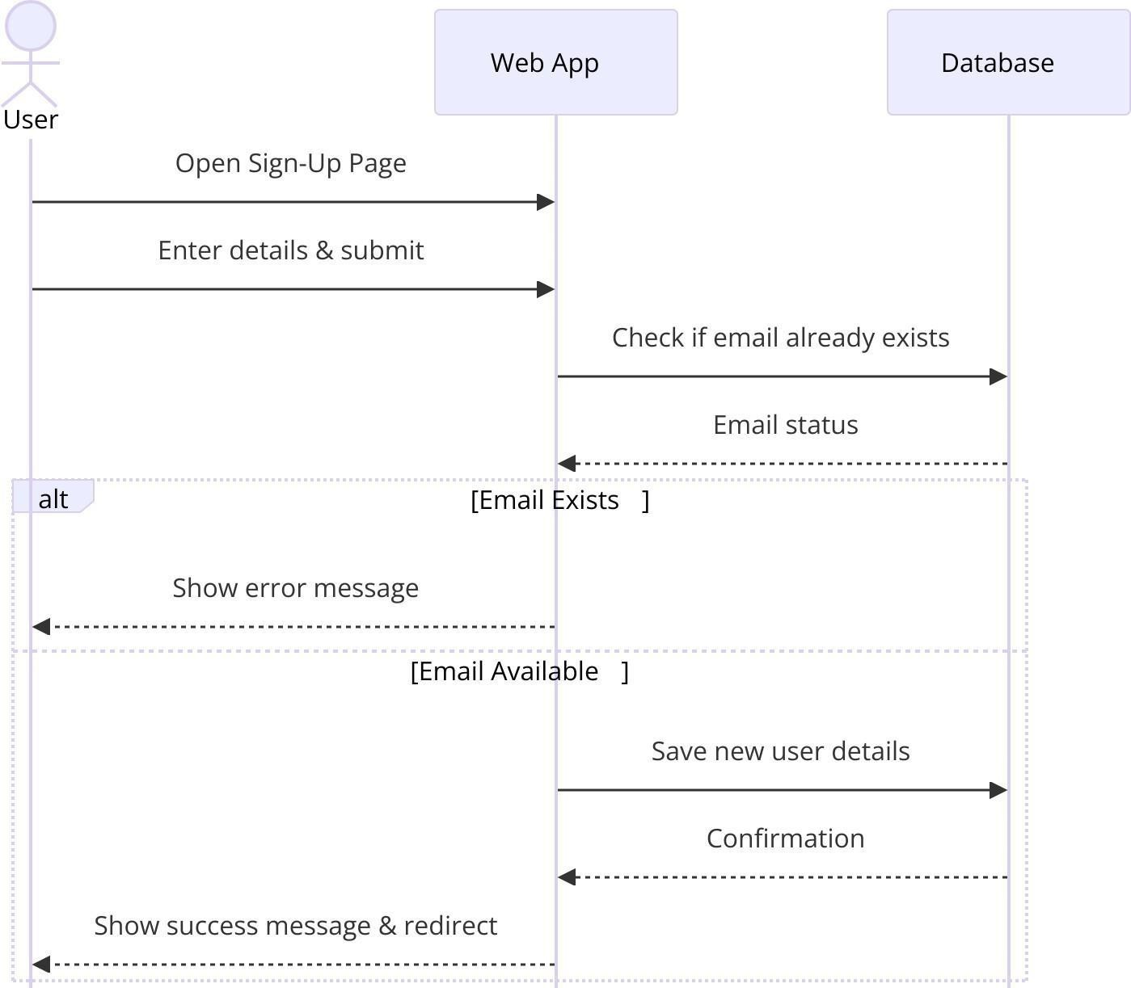

- Sign-up Sequence Diagram

Sign-in Sequence diagram:

This Login Sequence Diagram is representing the user login process in the Inventory Management System (IMS). It shows the interaction between the user, IMS, and the authentication server for validating credentials, leading to either successful authentication or an error message.

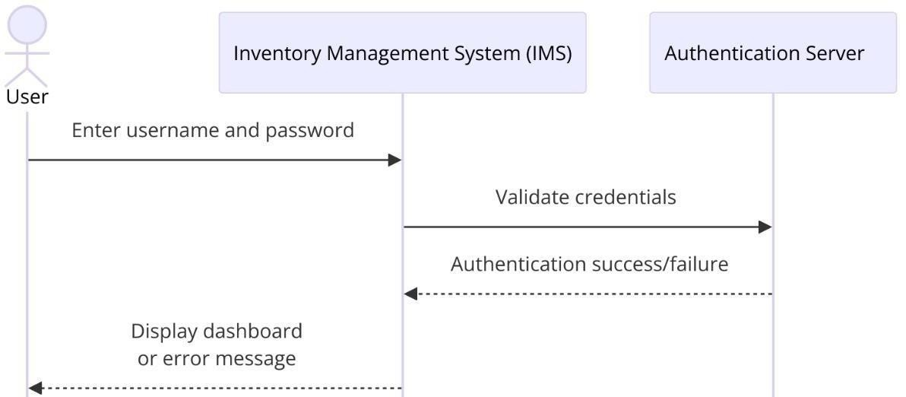
- Sign-in Sequence Diagram

Create Event Sequence Diagram:

The event sequence diagrams illustrate the interactions between a user, a web application, and a database for two distinct processes: event creation and user sign-up. They visually represent the flow of messages and actions, including error handling and alternative flows, using standard sequence diagram notation.

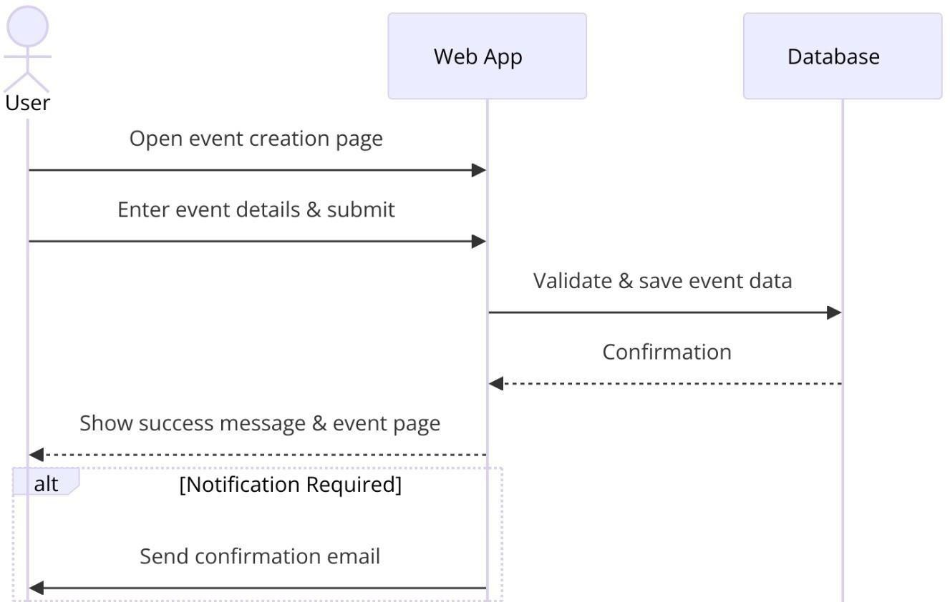
- Event Sequence Diagram

Architecture Design Diagram :

This architecture design diagram represents a three-layered structure of a web-based system. The Presentation Layer (Front End) handles user interactions via HTTP requests, while the Business Layer (Back End) processes authentication, API calls, and role-based access. The system integrates with a Database and optional Third-Party Services to manage data and additional functionalities.

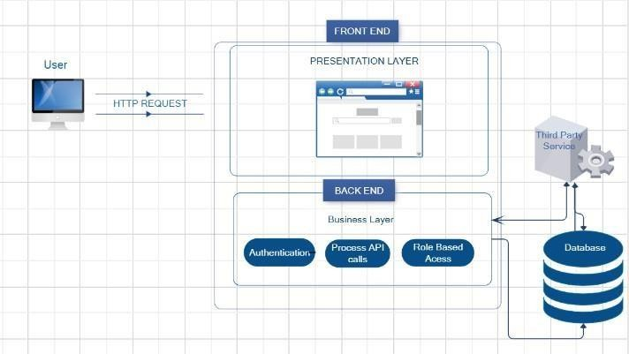
- Architecture Design Diagram

Database Diagram

This Database Design Diagram illustrates the entities and relationships in the Inventory Management System:
User: Holds user details like role and email.
Requisition: Tracks item requests with status, linked to users and inventory. Inventory: Manages item details like quantity and category.
Supplier: Optionally links suppliers to inventory items.
It shows how users place requisitions, connected to inventory and suppliers.
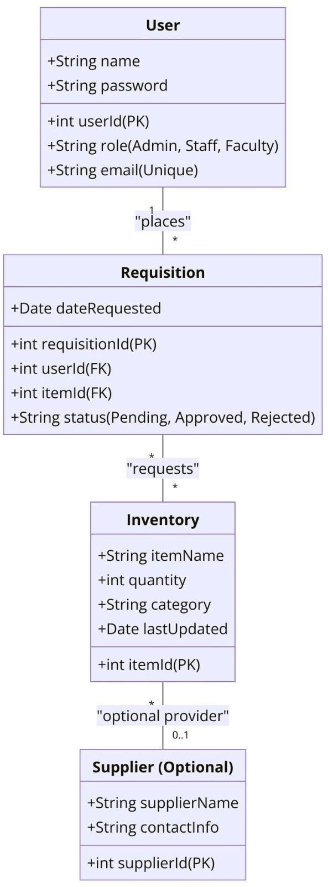
8-Database Diagram

Class Diagram
This Class Diagram outlines user roles and functionalities in an Inventory Management System:
  - User: Base class with attributes (e.g., userId, email) and methods like login and logout.
  - Admin: Manages users, inventory, and requisitions.
  - Staff: Handles stock tracking, requisitions, and audits.
  - Faculty: Requests items and tracks orders.
It highlights role-specific responsibilities and shared behaviors.

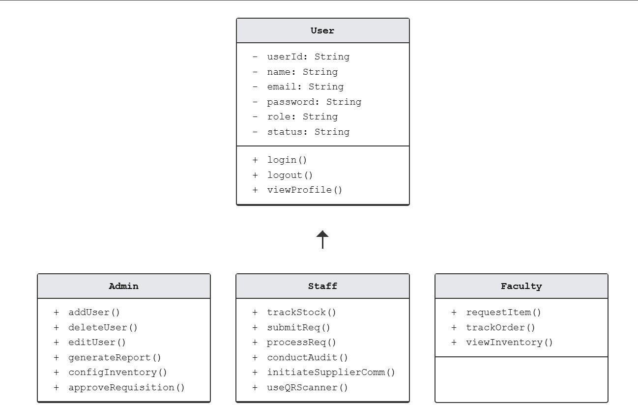

9-Class Diagram

Interface Design:
Here are some of the interfaces that have been implemented.
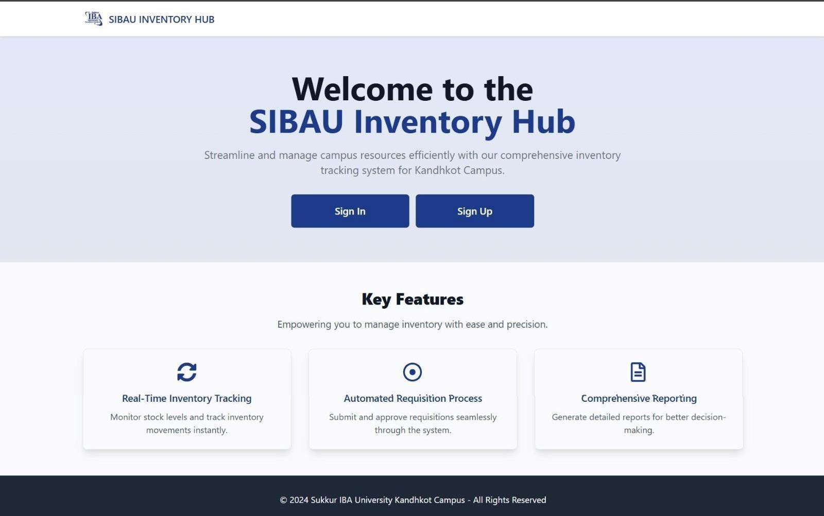
10-Landing page of the website

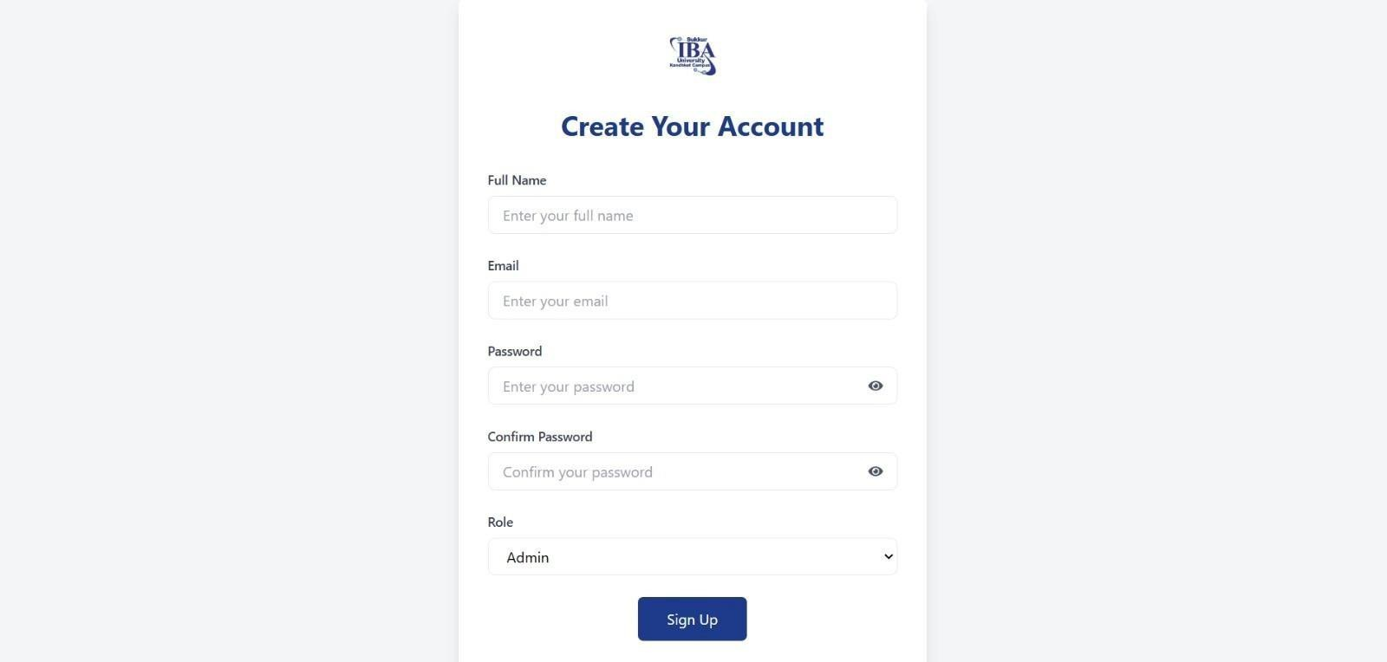
11- Sign-up page

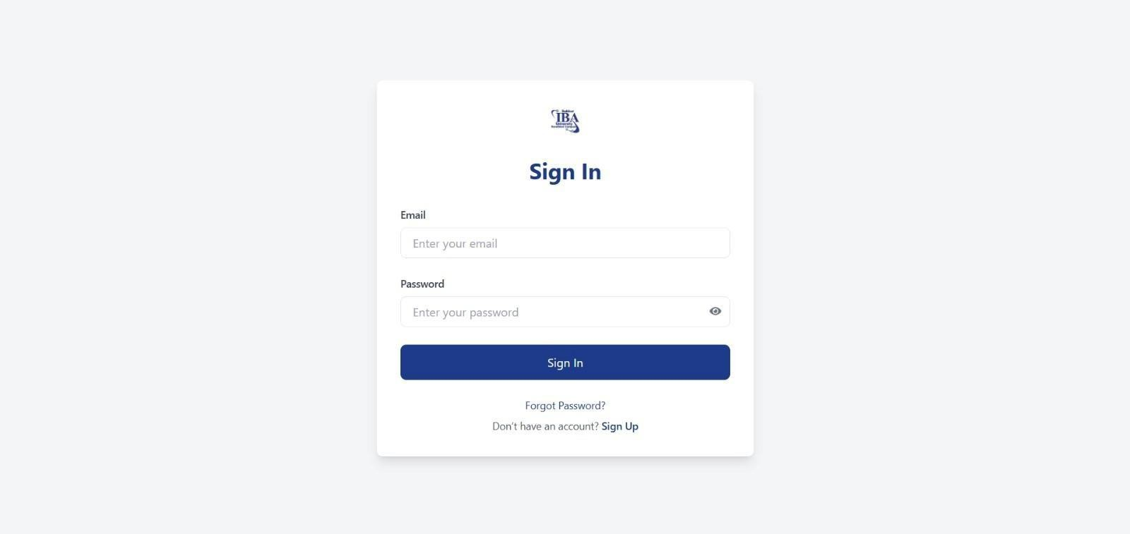
- Sign-in page

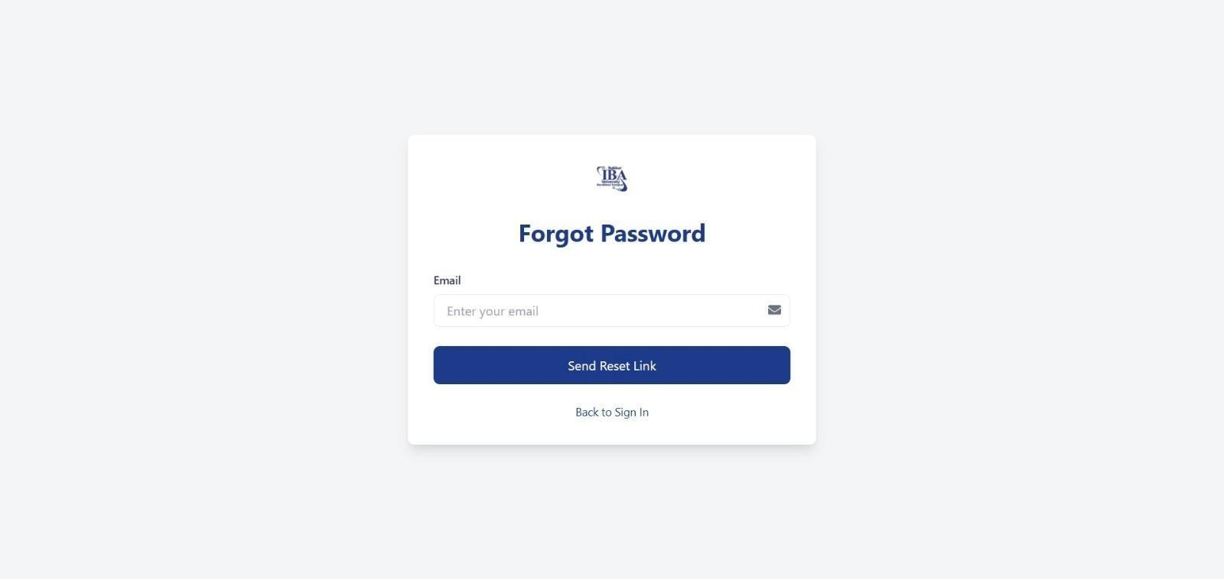
- Forgot password page

Test Cases:
In this section of document, some of the test cases have been written.

Valid Sign-up Details
Test case Id | 01
Test Scenario: User provide details to get registered into the system
Pre-condition | User should have the knowledge of how to use a website User should be connected to the internet
Steps# | Test Steps
1 | Go to the Signup screen
2 | Enter Full name
3 | Enter email
4 | Enter Password
5 | Confirm Password
6 | Choose Role either Admin, Staff or faculty
7 | Click Signup
Test data:
Fullname : Ajaykumar Email: sejalseetlani@gmail.com Password: ajay123@ Confirm password: ajay123@
Role: Admin
Expected outcome |  | User is registered into the system  Main dashboard appears
Actual results: |  | User is registered

Invalid Sign-up details
Test case Id |  | 02
Test Scenario: User provide details to get registered into the system
Pre-condition |  | User should have the knowledge of how to use a website User should be connected to the internet
Steps # | Test Steps
1. | Go to the Signup screen
2. | Enter Fullname
3. | Enter invalid Username
4. | Enter invalid Password
5. | Confirm password is changed from original one
6 | Choose Role
7 | Click Signup
Invalid Test data:
fullname:M Email: sejal Password:mal
Confirm password: sej
Expected outcome: |  | User is not registered into the system User must put correct data  System should ask user to re Enter the data Correctly
Actual results: |  | User is registered

Empty Signup details
Test case Id |  | 03
Test Scenario: User does not provide details to get registered into the system
Pre-condition |  | User should have the knowledge of how to use a website User should be connected to the internet
Steps # | Test Steps
1. | Go to the Signup screen
2. | User does not enter any field
3. | Click Signup
Test data:
fullname Username: Password: Phone:
Expected outcome: |  | User is not registered into the system User must be on signup screen  System should ask user to enter the data
Actual results: |  | User is registered

Sign-in valid credentials
Test case Id |  | 04
Test Scenario: Verify that the users are authenticated
Pre-condition |  | User must be registered into the system
Steps # | Test Steps
1. | Go to the login screen
2. | Enter valid Email
3. | Enter valid Password.
4. | Click Sign-in
Test data:
Username: ajaykumar@gmail.com Password: sejal123
Expected outcome: |  | User is logged into the system successfully Display main dashboard.
Actual result |  | User logins successfully

Sign-in invalid credentials
Test case Id |  | 05
Test Scenario: Verify that the users are not authenticated
Pre-condition |  | User must be registered into the system
Steps # | Test Steps
1. | Go to the login screen
2. | Enter invalid Username
3. | Enter invalid Password
4. | Click Login
Test data:
- Username:ajaykumar@gmail.com Password: sejal123
- Username: ajay
Password: 12
Expected outcome: |  | Main dashboard should not be displayed to the user User should get an error message  User should be asked to re-Enter the data
Actual results |  | User is logged into the system

Empty Sign-in credentials
Test case Id |  | 06
Test Scenario: User does not provide login credentials
Pre-condition |  | User must be registered into the system
Steps # | Test Steps
1. | Go to the login screen
2. | User does not enter any field
3. | Click Login
Test data:
Username: Password:
Expected outcome: |  | Main dashboard should not be displayed to the user User should get an error message  User should be asked to enter the data
Actual results |  | User is logged into the system

Forgot Password Functionality
Test Case-Id |  | 07
Test Scenario: Verify that the "Forgot Password" functionality works as expected.
Pre-condition |  | The user should have an account in the system.  The system should be connected to the internet.  The email address should be valid and associated with the registered account.
Steps# | Test Steps
1 | Go to the forgot password page
2 | Enter the registered email address in the "Email" field.
3 | Click on the "Send Reset Link" button
Test data:
Email: sejalseetlani@example.com
Expected outcome: |  | The user can use the reset link to reset their password.  The system sends a password reset link to the registered email address.  A success message is displayed on the screen, e.g., "Reset link sent to your email."
Actual result |  | The reset link is sent successfully.

Forgot Password With Invalid Email
Test case Id |  | 08
Test Scenario: Verify that the system does not send a reset link for invalid or unregistered email addresses.
Pre-condition |  | The system should be connected to the internet.
Steps # | Test Steps
1. | Open the "Forgot Password" page
2. | Enter an invalid or unregistered email address in the "Email" field
3. | Click on the "Send Reset Link" button
Test data:
Email: Invalid Email Example 1: notanemail
Invalid Email Example 2: unregistered@example.com
Expected outcome: |  | The system displays an error message, e.g., "Invalid email address" or "Email not registered."  No reset link is sent.
Actual results |  | The system correctly identifies invalid email addresses.

Forgot Password with Empty Email Field
Test case Id |  | 09
Test Scenario: Verify that the system does not process the request if the email field is left empty.
Pre-condition |  | The system should be connected to the internet.
Steps # | Test Steps
1. | Open the "Forgot Password" page
2. | Leave the "Email" field empty.
3. | Click on the "Send Reset Link" button
Test data:
- Email:
Expected outcome: |  | The system displays an error message, e.g., "Email field cannot be empty."  No reset link is sent..
Actual results |  | The system correctly prevents processing when the email field is empty

10. References:

- IEEE Std 1016-2009, "IEEE Standard for Information Technology—Systems Design—Software Design Descriptions."
- Fowler, M. (2003). UML Distilled: A Brief Guide to the Standard Object Modeling Language. Addison-Wesley.
- Elmasri, R., & Navathe, S. B. (2016). Fundamentals of Database Systems. Pearson.

- Chodorow, K. (2013). MongoDB: The Definitive Guide. O'Reilly Media.

- Myers, G. J., Sandler, C., & Badgett, T. (2012). The Art of Software Testing. Wiley.

- Richards, M. (2015). Software Architecture Patterns. O'Reilly Media.

11. Appendices
Appendix A: List of Diagrams
- Figure 1: Entity Relationship Diagram (ERD)
- Figure 2: Use Case Diagram
- Figure 3: General Sequence Diagram
- Figure 4: Sign-up Sequence Diagram
- Figure 5: Sign-in Sequence Diagram
- Figure 6: Create Event Sequence Diagram
- Figure 7: Architecture Design Diagram
- Figure 8: Database Diagram
- Figure 9: Class Diagram
- Figure 10: Landing Page Interface
- Figure 11: Sign-up Page Interface
- Figure 12: Sign-in Page Interface
- Figure 13: Forgot Password Page Interface

Appendix B: Team Members

Appendix C: Supervisory Team
  - Supervisor: Mr. Noor Nabi Dahar

Appendix D: Tools & Technologies Used
- Frontend: React.js
- Backend: Node.js, Express.js
- Database: MongoDB
- Version Control: GitHub
- Design & Diagrams: Draw.io

